Project One

Allen Worthley  
mworthley3@gatech.edu

# Contents

## Question 1

Based on empirical data, the probability of winning $80 is 100% in experiment one. The calculation for this probability is the count of episodes ending with a $80 winning balance divided by the total episodes (1000). As shown in Figure 2, the mean reaches $80 around 200.

## Question 2

The expected value after 1000 spins for is 80. This value is the average winning balance for all 1000 episodes held after 1000 spins. The expected value is probability of each unique balance multiplied by the balance. Essentially this is a weighted average of the winning balances based on the probability. As the probability of each event is equal empirically, the expected value is merely a simple average calculation across the episode results. The formula is as follows: expected value = $\frac{\sum_{i=0}^{1000}{Winning Balance_{i}}}{1000}$ where *i* represents the spin.

## Question 3

In experiment 1, the mean plus and minus standard deviation bands converge to the mean after 200 spins. Convergence occurs due to the assumption of unlimited bankroll and its implications on the standard deviation. As there is no loss limit, there are large runs of continual losses creating a large amount of initial variability as shown in Figure 6. However, the naïve code also assumes that there are continuous funds to bet and eventually the strategy recovers from the variability given enough spins to win. Therefore, the standard deviation converges to zero as more and more episodes win which results in a convergence of the upper and lower bands to the mean.

## Question 4

In experiment 2, the probability of winning $80 after 1000 spins is 0.638. The probability is calculated as the count of episodes where the 1000th spin held $80 as the winning balance divided by the total episodes.

## Question 5

The expected value of winnings after 1000 spins is -41.508. This calculation is the average of the balances after 1000 spins. Also, it is mathematically equivalent to multiply the probability of winning (0.638) by the result of the outcome ($80) and add this to the probability of losing times the loss (-$256) which provides the same result.

## Question 6

In experiment two, there is a limited loss of -$256 and a maximum gain of $80. The upper and lower bands diverge from the mean as spins increase at a slower and slower pace as Figure 4 displays. This is due to how the standard deviation changes throughout each spin. In Figure 7, the standard deviation increases sharply but then flattens out as spins increase and the limited losses or maximum gains occur. The repeated $256 or $80 towards the later number of spins stabilizes the standard deviation at around $150. This translates to the upper and lower bounds converging to $109 (– 41 + 150) and -191 (-41-150) respectfully.

## Question 7

Using an expected value encapsulates more information about the distribution and output of events. Especially in a random walk experiment like gambling, one single episode or night in Vegas is not emblematic of the population of outcomes or the likelihood of the same outcome. As shown in experiment 2, the expected value is negative indicating that on average a player will lose. However, the probability of winning $80 is more than 50%! These two statistics seem contradictory, but the expected value considers that the player will lose $256 the other half of the time.

# Figures

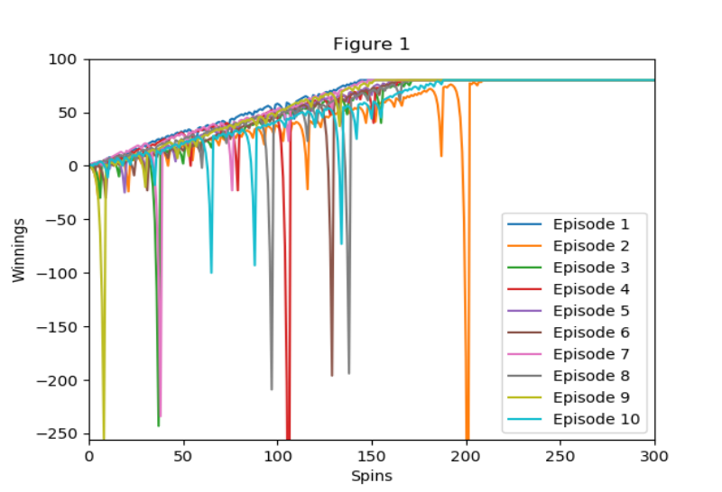

1. Experiment 1 with only 10 episodes, progression of winnings by spins.

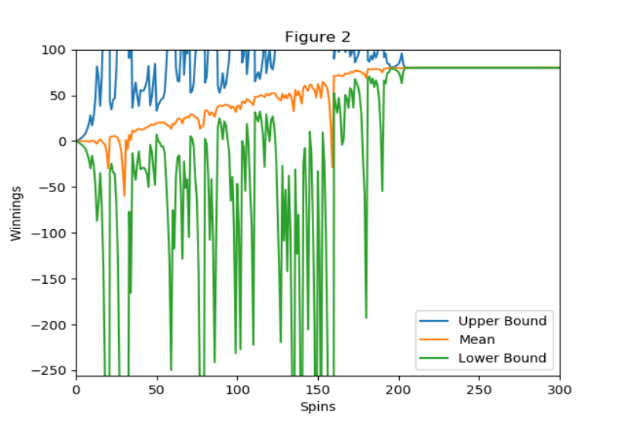

1. Experiment 1 average winning balances with upper and lower bounds.

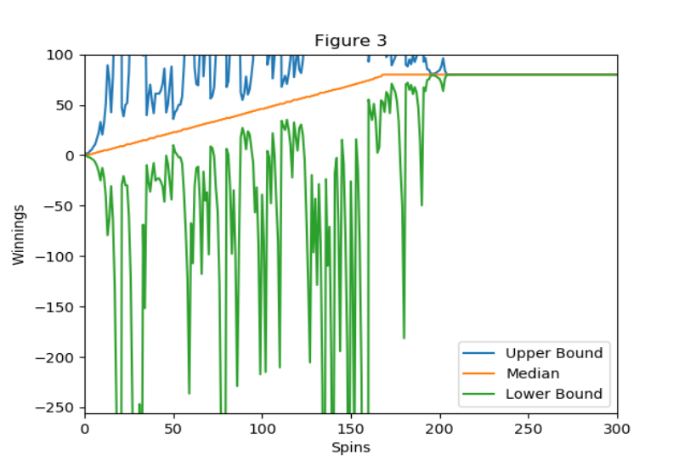

1. Experiment 1, median winning balances with upper and lower bounds.

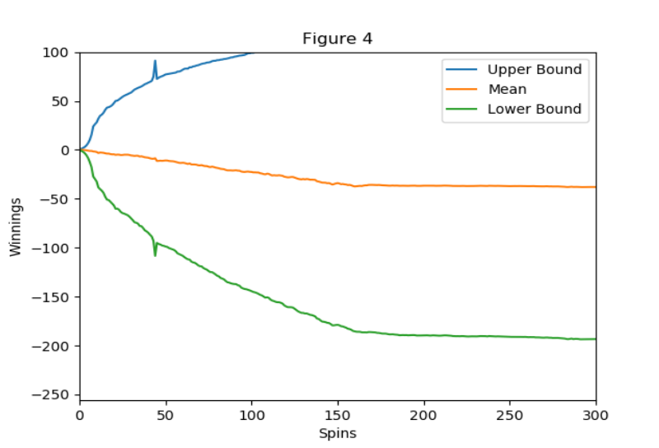

1. Experiment 2, average winning balances with upper and lower bounds.

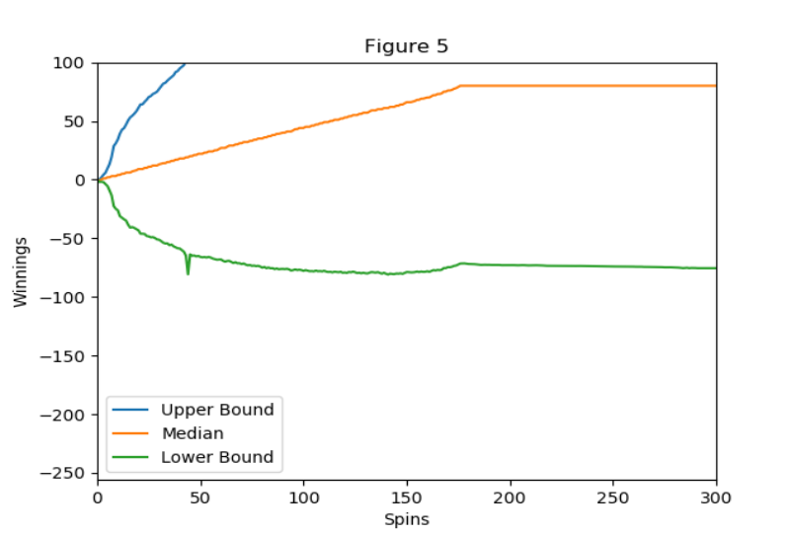

1. Experiment 2, median winning balances with upper and lower bounds.

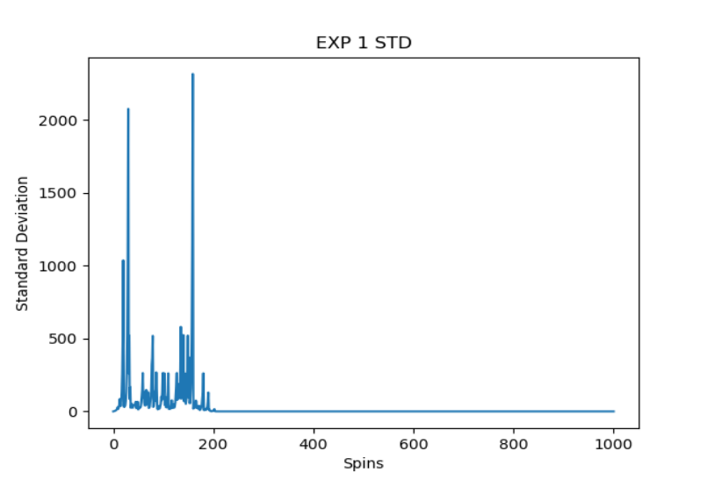

1. Experiment 1, standard deviation of winnings by number of spins.

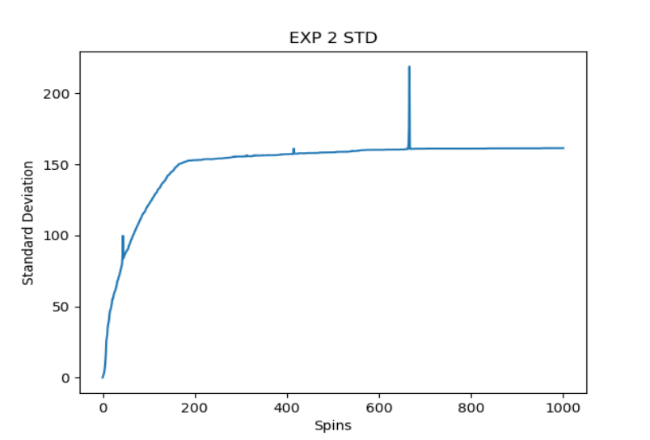

1. Experiment 2, standard deviation of winnings by number of spins.